Network Troubleshooting, Management, Monitoring and Optimization
Tasks
1. Use the Windows command prompt to run the command ipconfig /all on your computer and take a screenshot of the output. Identify and write down your IPv4 address, subnet mask, default gateway, and DNS servers as shown in the result.
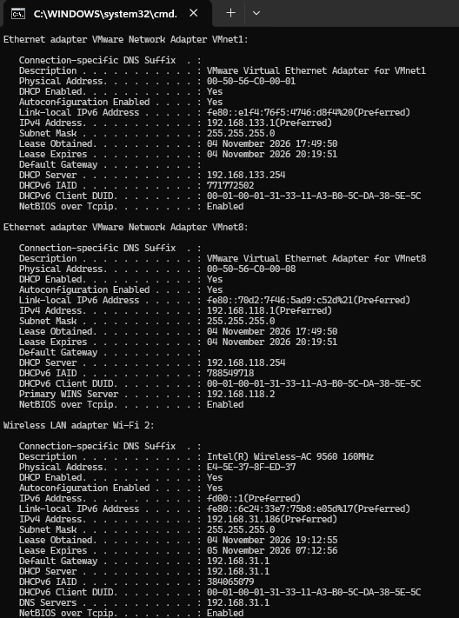

Network Configuration Details (Wi-Fi 2)
- IPv4 Address: 192.168.31.186
- Subnet Mask: 255.255.255.0
- Default Gateway: 192.168.31.1
- DNS Servers: 192.168.31.1
2. Simulate a network connectivity issue by disconnecting your Wi-Fi or Ethernet cable, then use the ping command to check connectivity to www.google.com. Reconnect and repeat the ping. Write a short note on the difference in results and what each status means.
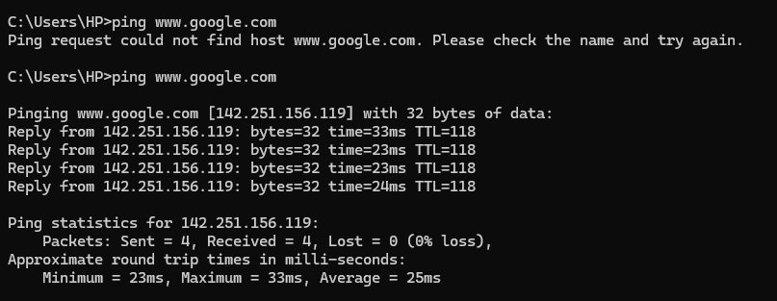

Network Connectivity Simulation & Analysis

1. Disconnected State Output (ping [www.google.com](https://www.google.com))
- Command Result: Ping request could not find host [www.google.com](https://www.google.com). Please check the name and try again.
- Status Meaning: The device is disconnected from the network, so it has no active local interface or IP configuration. As a result, the system cannot contact a DNS server to resolve [www.google.com](https://www.google.com) into an IP address, nor can it route data packets outside the machine.

2. Reconnected State Output (ping [www.google.com](https://www.google.com))
- Command Result:
  - Target IP: 142.251.156.119
  - Packets: Sent = 4, Received = 4, Lost = 0 (0% loss)
  - Round-Trip Times: Minimum = 23ms, Maximum = 33ms, Average = 25ms
- Status Meaning: The network interface is reconnected and has obtained an IP configuration. The system successfully uses DNS to resolve [www.google.com](https://www.google.com) to 142.251.156.119 and sends ICMP Echo Request packets, confirming end-to-end connectivity with 0% packet loss.

3. Note on the Difference
- Disconnected State: Fails at the initial DNS lookup/routing phase due to the lack of an active physical/wireless network connection.
- Reconnected State: Completes DNS name resolution and successfully establishes two-way packet communication with Google's destination server at an average latency of 25ms.

3. Open Task Manager or Resource Monitor on your system and monitor network usage for 5 minutes while streaming a YouTube video. Record the peak network usage value and note which process used the most bandwidth during this time.

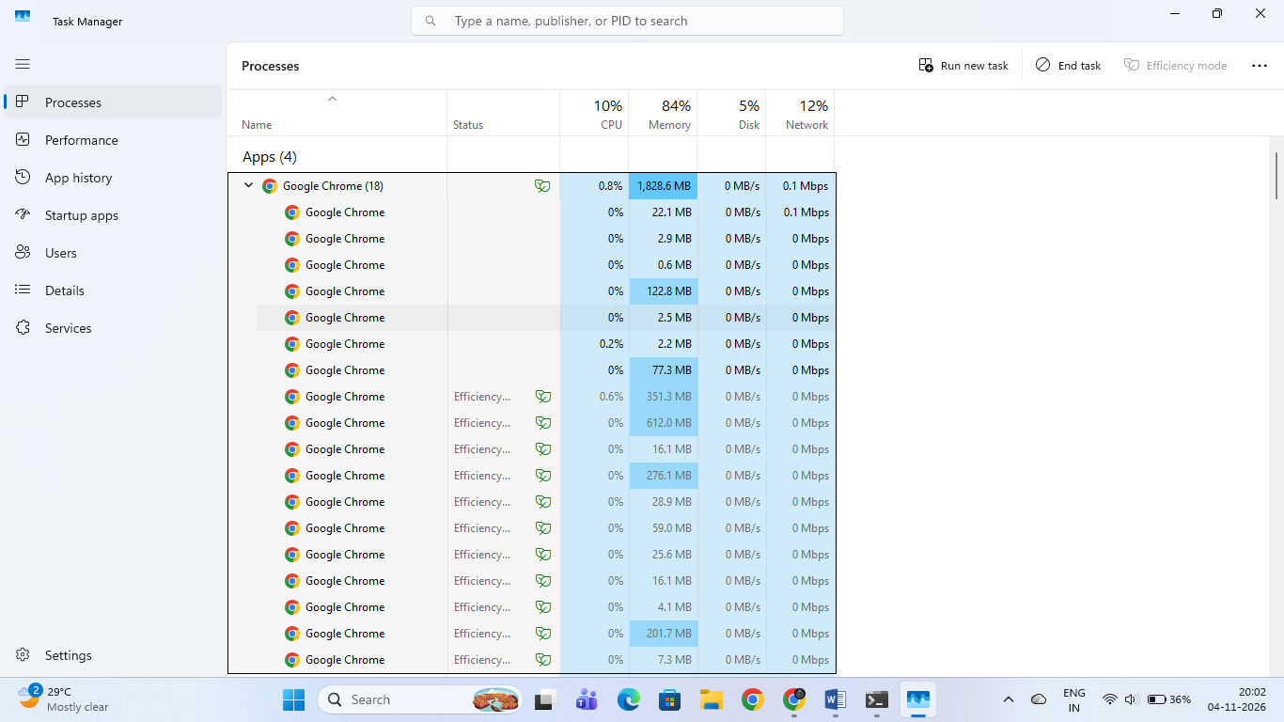

Task Manager Network Monitoring Results
- Top Bandwidth-Consuming Process: Google Chrome (chrome.exe)
- Peak Network Usage: 0.1 Mbps
- Total Memory Usage: 1,828.6 MB (distributed across 18 active browser sub-processes)

4. Download and install Wireshark (or use an online packet capture demo if installation is not possible). Capture at least 30 seconds of network traffic while browsing Flipkart or Instagram Web, then filter the packets to show only HTTP or HTTPS traffic. List 3 types of information you can see in these filtered packets. Use the filter bar in Wireshark and try http or https as the filter keyword.
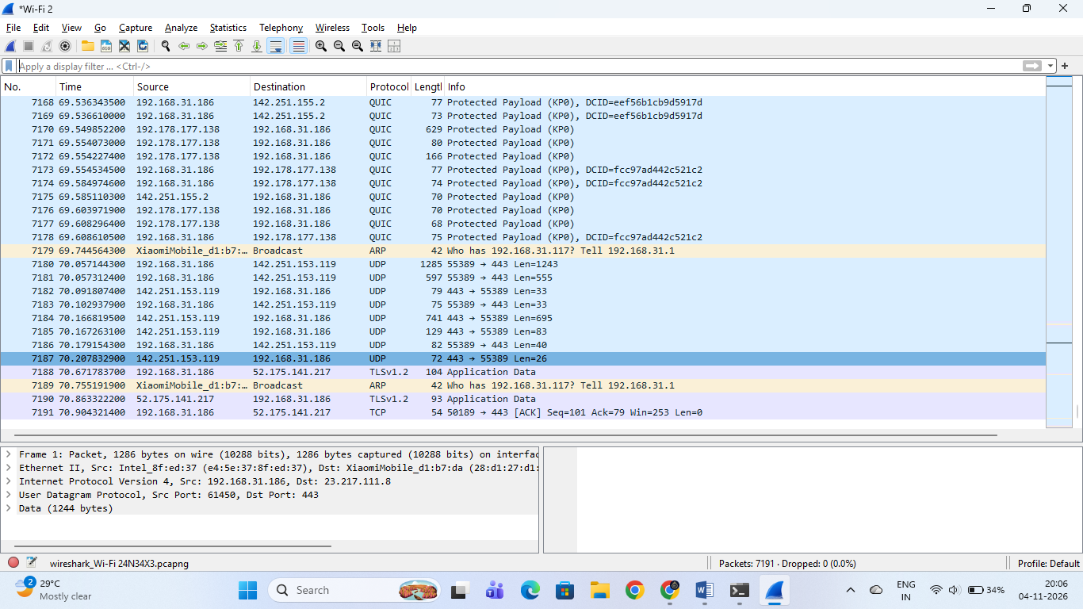

Wireshark Packet Capture Analysis
- Active Interface: Wi-Fi 2
- Observed Protocols:
  - QUIC: Quick UDP Internet Connections packets between your local IP (192.168.31.186) and Google/external servers (142.251.155.2, 192.178.177.138).
  - ARP: Address Resolution Protocol broadcast packets (Who has 192.168.31.117? Tell 192.168.31.1) handling local MAC address resolution.
  - UDP: User Datagram Protocol packets flowing on port 443.
  - TLSv1.2: Transport Layer Security encrypted application data communicating with external endpoints (52.175.141.217).
- File Name: wireshark_Wi-Fi 24N34X3.pcapng
5. Imagine your friend is complaining about slow internet while gaming online. Use ChatGPT or any AI tool to generate a troubleshooting checklist (at least 5 points) for optimizing home network speed and reliability. Paste the AI's response and highlight one suggestion you would try first.

Troubleshooting Checklist for Slow Internet While Online Gaming

1. Introduction
Slow internet and high ping can affect online gaming. A stable and reliable home network is important for smooth gaming without lag or disconnections.

2. Troubleshooting Checklist
Here are 7 suggestions to improve home network speed and reliability:
S.No. | Troubleshooting Action | Solution
1. | Restart the Router | Restart the Wi-Fi router to refresh the network connection.
2. | Use an Ethernet Cable | Connect the gaming PC or console directly to the router using a LAN cable for a stable connection.
3. | Check Router Placement | Keep the router in an open and central location to improve Wi-Fi signals.
4. | Reduce Connected Devices | Disconnect unnecessary devices using the same Wi-Fi network to reduce network traffic.
5. | Update Router Firmware | Install the latest router firmware to improve performance and security.
6. | Close Background Applications | Close unnecessary downloads, streaming apps and updates while gaming.
7. | Check Internet Speed and Ping | Run an internet speed test to check download speed, upload speed and latency. Contact the ISP if the problem continues.

3. Suggestion I Would Try First
My First Choice
I would first connect my gaming device directly to the router using an Ethernet cable.
Reason: An Ethernet connection is generally more stable than Wi-Fi and can reduce wireless interference and lag.

4. Conclusion
By following these troubleshooting steps, we can improve home network performance, reduce gaming lag and maintain a stable internet connection.

5. Result
Successfully generated a seven-point troubleshooting checklist for improving home network speed and reliability during online gaming.

